
Contact: Swallow Yan, Executive Director, Chinese Association of Iowa
515-988-0901, IowaChinese@yahoo.com, www.IowaChinese.org

The Chinese Association of Iowa Cordially Invites You to
The 2009 Iowa Chinese New Year Celebrations


Ox Years Are 1901, 1913, 1925, 1937, 1949, 1961, 1973, 1985, 1997.

Proudly Co-presented by the Chinese Association of Iowa and the
West Des Moines Community Schools District

Saturday, Jan. 24, 2009, 11am-9pm
Valley High School,
3650 Woodland Ave, West Des Moines

Opening Remark by the Deputy Chinese Consul General Maoming Chu
Traditional Music by Shijiazhuang Foreign Language School, Hebei, China
Passport and Visa Services by the Chinese Consulate General, Chicago

Free Admission for celebrating Chinese heritages, cultures, community, and achievements. Enjoy friendship, cultural demonstrations, music and dancing, arts, food, and children activities.

Funding for The 2009 Iowa Chinese New Year Celebrations was provided by

Gold Sponsors: Kemin Industries and Wells Fargo

Silver Sponsors: Bankers Trust and Iowa Realty

Bronze Sponsors: 1st Consulting, Chinese Language and Cultural Academy, CK International, Community CPA & Associates, Faegre & Benson LLP, Green Yoga House, David and Barbara Hurd, Nationwide, John Pestotnik and Cindy Hewett, Panda Garden Restaurant, RDG Planning and Design, and Shine-Link International Group

Additional support was given by: Hebei Chinese Language Program (HCLP), Iowa Chinese Financial Group (ICFG), Iowa Youth Leadership International (IYLI), and
Iowa Chinese Young Artist Council (IYAC).

Sponsorship and Exhibiting Opportunities

Gold Level: $3,000 | Sliver Level: $2,000 | Bronze Level: $1,000
$100 for each table to promote your organizations or businesses
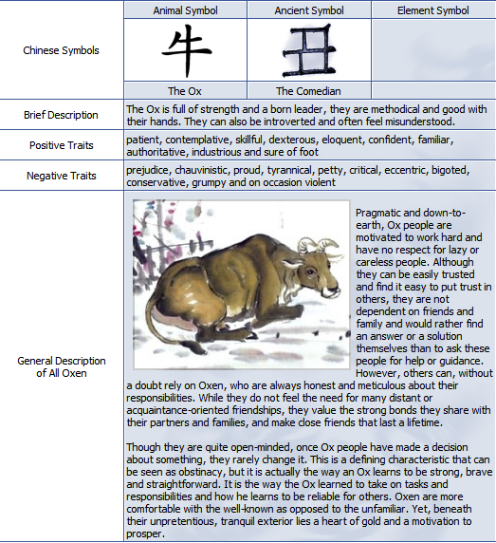

About Our Sponsors

The Chinese Association of Iowa appreciates the past sponsors of the Iowa Chinese New Year Celebrations in 2004, 2005, 2006, 2007 and 2008:

1st Consulting, Ankeny Community School District, Bankers Trust, Language and Cultural Academy, CK International, Community CPA and Associates, DMACC, Drake University, Faegre and Benson LLP, Gift of Love International Adoptions, Golden Teapot, Holmes Automobile Group, Iowa Finance Authority, Iowa Arts Council, Iowa Sister States, Iowa Realty, Kemin Industries, Meredith, Nationwide, Panda Garden Restaurant, Pioneer Hi-bred International, RDG Planning and Design, Sams Club, Townsend Engineering, Waukee Community School District, and Wells Fargo.

About Past Chinese New Year Celebrations

The Chinese Association of Iowa has hosted the annual Iowa Chinese New Year since 2004. The New Year Celebrations have been rotated to different areas to meet the community diversified culture needs: DMACC Ankeny Campus (2004), Drake University and DMACC Ankeny Campus (2005), Drake University (2006), Ankeny Northview Middle School and High School (2007), and Waukee High School (2008). This year West Des Moines will co-host the celebration of the Chinese New Year of OX. The West Des Moines School District has offered the first Chinese language class in suburb since Fall 2008.

Sat., Jan. 24, 2009 New Year Program, Valley High School, West Des Moines

11am-3pm The Iowa Chinese New Year Celebrations. Free Admission.

The Annual Chinese New Year Poster Contest Exhibit and Award Ceremony

Children activities with traditional and inflatable’s

Chinese cooking demonstrations

Chinese food and drinks

Chinese music and dancing

Chinese calligraphy and painting demonstrations

Chinese martial arts demonstrations

Chinese Tai-Chi demonstrations

Chinese arts and art crafts for sale/silent auction and exhibitions

Iowa Chinese t-shirt

Lucky winners for the door prizes

4-6pm The Chinese New Year Dinner and the Reception for the Annual Iowa Chinese Achievement Awards with live music of the Chinese traditions by students from Hebei, China. $25 per person in general, $5 per person for Chinese Association of Iowa members. RSVP to Swallow Yan at IowaChinese@yahoo.com

6-7pm The Annual Iowa Chinese Achievement Award Ceremony. Free Admission.

7-9pm The Gala of the New Year Music and Dancing. Free Admission.
About the Chinese Zodiac
The Ox is the sign of prosperity through fortitude and hard work. This powerful sign is a born leader, being quite dependable and possessing an innate ability to achieve great things. As one might guess, such people are dependable, calm, and modest. Like their animal namesake, the Ox is unswervingly patient, tireless in their work, and capable of enduring any amount of hardship without complaint.
Ox people need peace and quiet to work through their ideas, and when they have set their mind on something it is hard for them to be convinced otherwise. An Ox person has a very logical mind and is extremely systematic in whatever they do, even without imagination. These people speak little but are extremely intelligent. When necessary, they are articulate and eloquent.
People born under the influence of the Ox are kind, caring souls, logical, positive, filled with common sense and with their feet firmly planted on the ground. Despite this fact, they still behave in a manner that professes complete and "utter" disregard. Security is their main preoccupation in life, and they are prepared to toil long and hard in order to provide a warm, comfortable and stable nest for themselves and their families. Strong-minded, stubborn, individualistic, the majority are highly intelligent individuals who don't take kindly to being told what to do.
The Ox works hard, patiently, and methodically, with original intelligence and reflective thought. These people enjoy helping others. Behind this tenacious, laboring, and self-sacrificing exterior lies an active mind.
The Ox is not extravagant, and the thought of living off credit cards or being in debt makes them nervous. The possibility of taking a serious risk could cause the Ox sleepless nights.
Ox people are truthful and sincere, and the idea of wheeling and dealing in a competitive world is distasteful to them. They are rarely driven by the prospect of financial gain. These people are always welcome because of their honesty and patience. They have many friends, who appreciate the fact that the Ox people are wary of new trends, although every now and then they can be encouraged to try something new.
It is important to remember that the Ox people are sociable and relaxed when they feel secure, but occasionally a dark cloud looms over such people and they engage all the trials of the whole world and seek solutions for them.
The Ox person is dependable, calm, methodical, patient, hardworking, ambitious, conventional, disciplined, steady, modest, fair-minded, logical, resolute, tenacious. They can also sometimes be stubborn, narrow-minded, materialistic, rigid, demanding and nurture grievances. The Ox can attain prosperity and success through fortitude, hard work and natural leadership qualities. Good dentists, surgeons, engineers, and archaeologists. Ox years include 1901, 1913, 1925, 1937, 1949, 1961, 1973, 1985, 1997.

